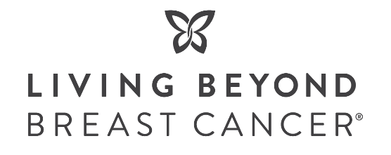
Breast Cancer Awareness Month 2023 – Thrive365

Please find pre-drafted social posts and creative graphics for your company/organization to tailor and use on your social media channels.
You can also choose to follow us and share our posts according to your social calendars. We kindly request that you tag Living Beyond Breast Cancer in any social posts about the campaign. See our branding guidelines for tips and recommended #.
- Facebook: https://www.facebook.com/livingbeyondbreastcancer
- X – formerly Twitter: https://twitter.com/LivingBeyondBC
- Instagram: https://instagram.com/livingbeyondbc
- LinkedIn: https://www.linkedin.com/company/living-beyond-breast-cancer
Channel | Copy | Creative
Facebook | We are proud to support @livingbeyondbreastcancer this October by [enter brand promotion details].  LBBC helps people diagnosed with breast cancer understand their options, make informed decisions, and connect to others who have been where they are for emotional support.  Sample CTA’s to choose from:  - Make a gift to LBBC today: https://bit.ly/3roXCK3  - Shop X and $/% will support LBBC’s programs and services. | 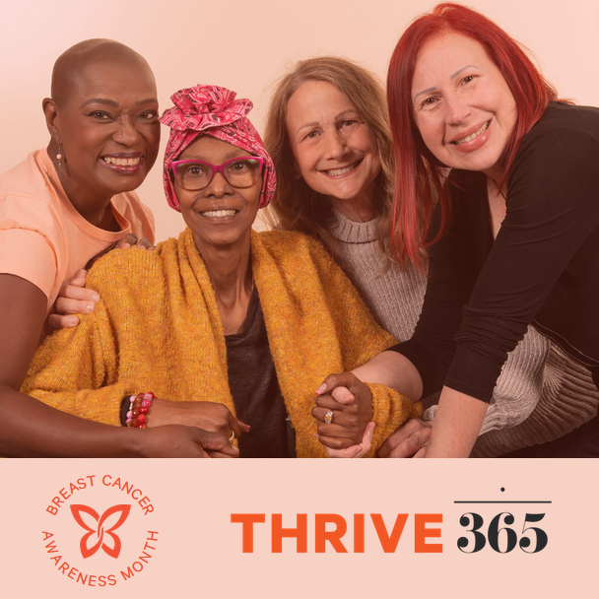
Facebook | This Breast Cancer Awareness Month, join us in supporting @livingbeyondbreastcancer. From [promo dates] we will be [donating x% of profits] to LBBC to support their programs and services that help those diagnosed with breast cancer. Shop now: [link] | Recommended graphic:  Product image with LBBC logo overlay
Facebook | Money is the last thing you should have to worry about when you are dealing with breast cancer. A survey of people who have or had cancer found 51% percent went into debt due to the cost of care. (ACS, 2022)  @livingbeyondbreastcancer provides grants to people in treatment to help pay the costs of rent, utilities, or other basic needs so they can focus on their health, not their bills.  We’re proud to partner with LBBC to help more women like Keneene #Thrive365.  Sample CTA’s to choose from:  - Make a gift to LBBC today: https://bit.ly/3roXCK3  - Shop X and $/% will support LBBC’s programs and services. | 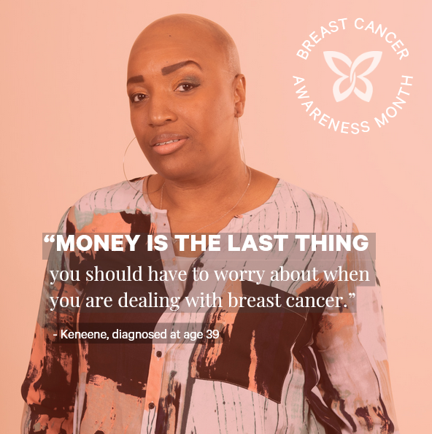
Facebook | Living Beyond Breast Cancer is one of the highest-ranking breast cancer charities in the U.S. When you support @livingbeyondbreastcancer, 83 cents of every dollar goes directly to education and support services for people diagnosed with breast cancer.  Make a donation to LBBC today: https://bit.ly/3roXCK3 | 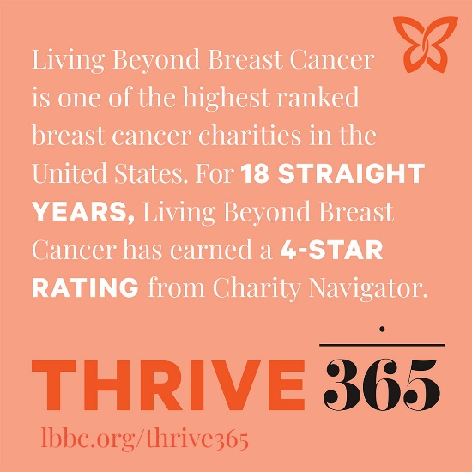
Facebook | Breast cancer is the most commonly diagnosed cancer among U.S. women. About 30% of all newly diagnosed cancers in women each year are breast cancer.  When someone hears the devastating words “you have breast cancer” @livingbeyondbreastcancer is there with trusted medical information, emotional support, and curated advice and stories of hope from their community of women who have been there.  With LBBC by your side, you are not alone. Learn more and share this valuable resource with a friend or family member who may need it: https://bit.ly/3rpr3M1 | 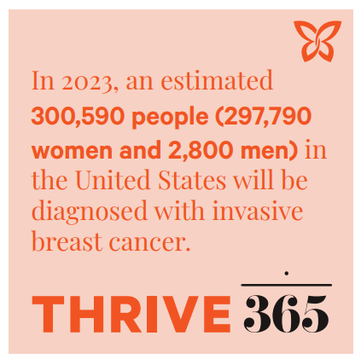
Facebook | This October, @livingbeyondbreastcancer is highlighting all the ways people THRIVE after a breast cancer diagnosis. People are taking control of their experience and thriving by making choices that express their values and individuality.  Show your support for LBBC and their inspiring community by following them on social media, sharing the thriver stories, and supporting their work with a donation: https://bit.ly/3roXCK3 | 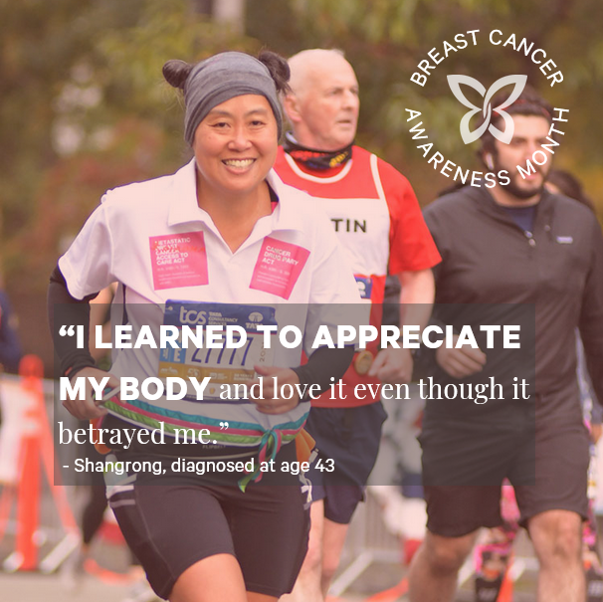
X (Formerly Twitter) | We are proud to support @LivingBeyondBC this October by [enter brand promotion details]. LBBC helps people diagnosed with #breastcancer by providing accessible trusted information and a community of support.  Sample CTA’s to choose from:  - Make a gift to LBBC today: https://bit.ly/3roXCK3  - Shop X and $/% will support LBBC’s programs and services. | 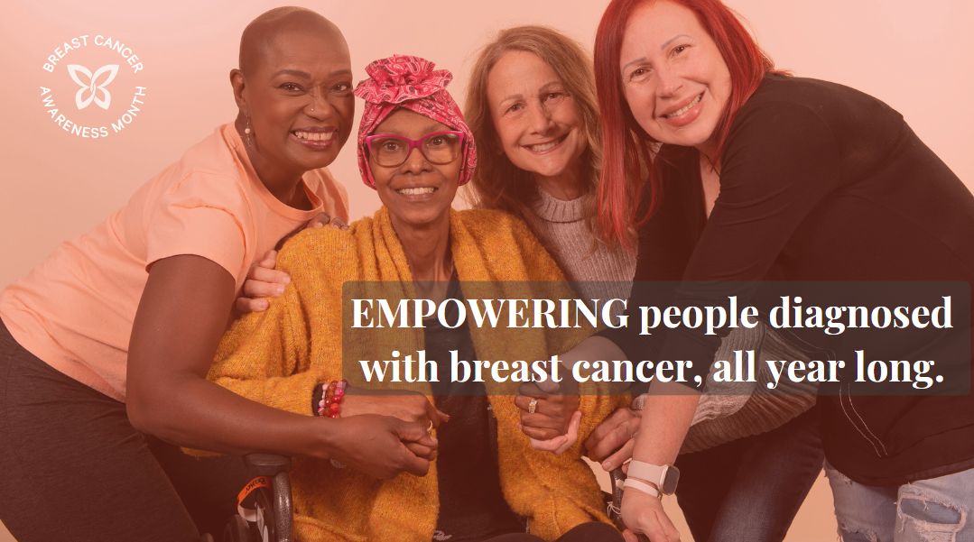
X (Formerly Twitter) | This #BreastCancerAwarenessMonth, join us in supporting @LivingBeyondBC. From [promo dates] we will be [donating x% of profits] to LBBC to support their programs and services that help those diagnosed with breast cancer. Shop now: [link] | Recommended graphic:  Product image with LBBC logo overlay
X (Formerly Twitter) | Money is the last thing you should worry about when you have #breastcancer. @LivingBeyondBC provides grants to people in treatment so they can focus on their health, not their bills. Help us help more women like Keneene #Thrive365.  Sample CTA’s to choose from:  - Make a gift to LBBC today: https://bit.ly/3roXCK3  - Shop X and $/% will support LBBC’s programs and services. | 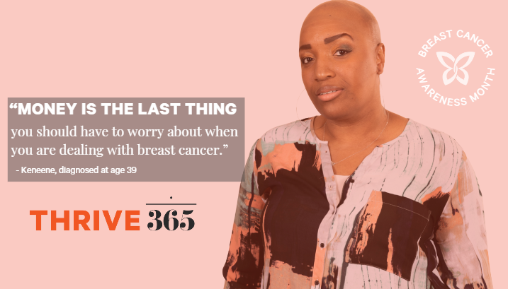
X (Formerly Twitter) | LBBC is one of the highest-ranking breast cancer charities in the U.S. When you support @LivingBeyondBC, 83 cents of every dollar goes directly to education and support services for people diagnosed with breast cancer. Make a donation to LBBC today: https://bit.ly/3roXCK3 | 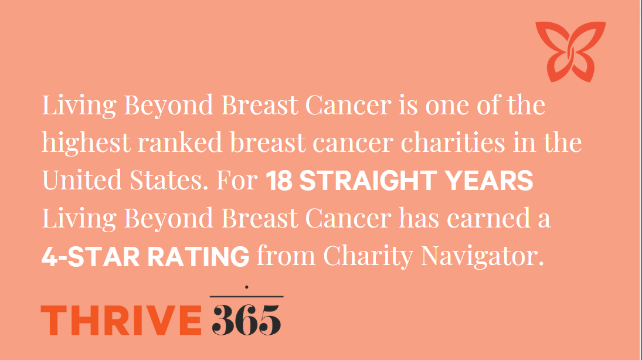
X (Formerly Twitter) | When someone hears the devastating words “you have breast cancer” @LivingBeyondBC is there with trusted medical information and a community of support. With LBBC by your side, you are not alone. Learn more and share this valuable resource: https://bit.ly/3rpr3M1 | 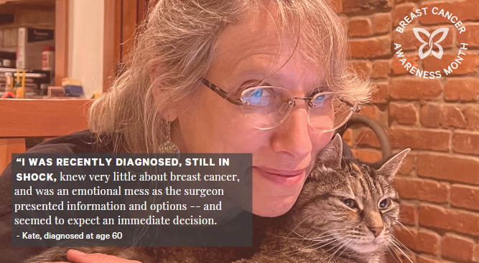
X (Formerly Twitter) | This October, @LivingBeyondBC is highlighting all the ways that people THRIVE after a breast cancer diagnosis. People are taking control of their experience and thriving by making choices that express their values and individuality.  Show your support for LBBC and their inspiring community by following them on social media, sharing the thriver stories, and supporting their work with a donation at https://bit.ly/3roXCK3 | 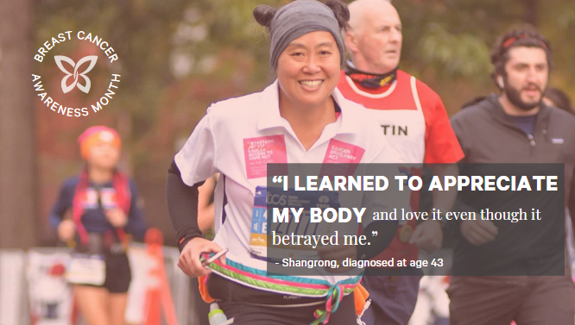
Instagram | We are proud to support @livingbeyondbc this October by [enter brand promotion details]  LBBC helps people diagnosed with breast cancer understand their options, make informed decisions, and connect to others who have been where they are for emotional support.  Sample CTA’s to choose from:  - Go to the link in our profile to make a gift to LBBC today. (Add https://bit.ly/3roXCK3 to your profile.)  - Shop X and $/% will support LBBC’s programs and services. | Same as FB image
Instagram | This Breast Cancer Awareness Month, join us in supporting @livingbeyondbc. From [promo dates] we will be [donating x% of profits] to LBBC to support their programs and services that help those diagnosed with breast cancer. Shop now at the link in our profile. | Same as FB image
Instagram | Money is the last thing you should have to worry about when you are dealing with breast cancer. A survey of people who have or had cancer found 51% percent went into debt due to the cost of care. (ACS, 2022)  @livingbeyondbc provides grants to people in treatment to help pay the costs of rent, utilities, or other basic needs so they can focus on their health, not their bills.  We’re proud to partner with LBBC to help more women like Keneene #Thrive365.  Sample CTA’s to choose from:  - Go to the link in our profile to make a gift to LBBC today. (Add https://bit.ly/3roXCK3 to your profile.)  - Shop X and $/% will support LBBC’s programs and services. | Same as FB image
Instagram | Living Beyond Breast Cancer is one of the highest-ranking breast cancer charities in the U.S. When you support @livingbeyondbc, 83 cents of every dollar goes directly to education and support services for people diagnosed with breast cancer.  Go to the link in our profile to make a gift to LBBC today. (Add https://bit.ly/3roXCK3 to your profile.) | Same as FB image
Instagram | Breast cancer is the most commonly diagnosed cancer among U.S. women. About 30% of all newly diagnosed cancers in women each year are breast cancer.  When someone hears the devastating words “you have breast cancer” @livingbeyondbc is there with trusted medical information, emotional support, and curated advice and stories of hope from their community of women who have been there.  With LBBC by your side, you are not alone. Go to the link in our profile to learn more and share this valuable resource with a friend or family member who may need it.  (Add https://bit.ly/3rpr3M1 to your profile.) | Same as FB image
Instagram | This October, @livingbeyondbc is highlighting all the ways people THRIVE after a breast cancer diagnosis. People are taking control of their experience and thriving by making choices that express their values and individuality.  Show your support for LBBC and their inspiring community by following them on social media, sharing the thriver stories, and supporting their work with a donation.  Go to the link in our profile to make a gift to LBBC today. (Add https://bit.ly/3roXCK3 to your profile.) | Same as FB image

*For LinkedIn, use the same messaging and tiles as Facebook. Be sure to tag LBBC using @Living Beyond Breast Cancer.

