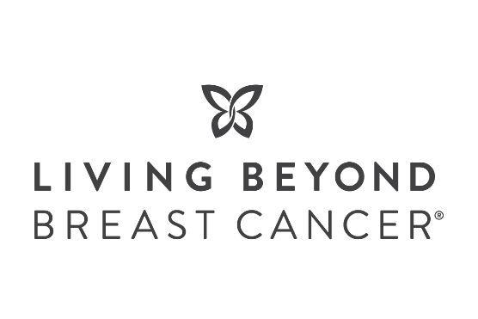
Breast Cancer Awareness Month 2024 – Thrive365

Please find pre-drafted social posts and creative graphics for your company/organization to tailor and use on your social media channels.
You can also choose to follow us and share our posts according to your social calendars. We kindly request that you tag Living Beyond Breast Cancer in any social posts about the campaign. See our branding guidelines for tips and recommended #.
- Facebook: https://www.facebook.com/livingbeyondbreastcancer
- X – (formerly Twitter): https://twitter.com/LivingBeyondBC
- Instagram: https://instagram.com/livingbeyondbc
- LinkedIn: https://www.linkedin.com/company/living-beyond-breast-cancer
Creative | Caption | Theme
FACEBOOK, INSTAGRAM, and LINKEDIN
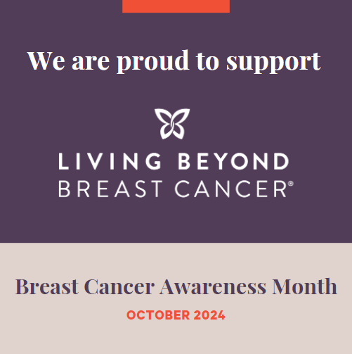  NOTE: You could also use your product / promotional image with LBBC graphic overlays | This #BreastCancerAwarenessMonth, we are proud to support @livingbeyondbreastcancer, one of the highest ranked U.S. charities.  Living Beyond Breast Cancer helps people diagnosed with breast cancer understand their options, make informed decisions, and connect to others who have been where they are for emotional support.  Sample CTA’s to use  - From [promo dates] we will be [donating x% of profits] to Living Beyond Breast Cancer to support their programs and services that directly help those diagnosed with breast cancer. Shop now @ [link]  - Make a gift to Living Beyond Breast Cancer today @ https://bit.ly/givetothrive365  - Learn more about breast cancer @ https://bit.ly/LBBClearn | Breast Cancer Awareness Month
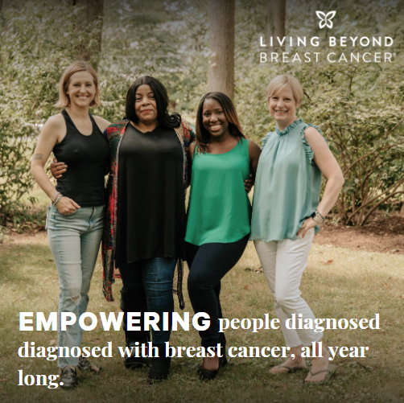 | Living Beyond Breast Cancer helps people diagnosed with breast cancer understand their options, make informed decisions, and connect to others who have been where they are for emotional support.  Each year, over 600,000 people find trusted information and a community of support through @livingbeyondbreastcancer.  Join us and donate to Living Beyond Breast Cancer this October to help more people #Thrive365: https://bit.ly/givetothrive365 | About LBBC
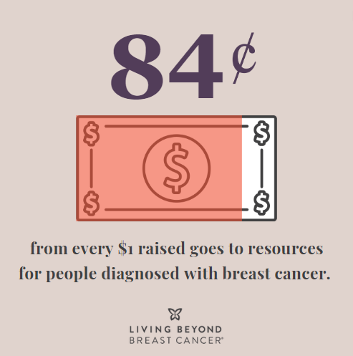 | Living Beyond Breast Cancer is one of the highest-ranking breast cancer charities in the U.S. When you support @livingbeyondbreastcancer, 84 cents of every dollar goes directly to education and support services for people diagnosed with breast cancer.  Sample CTA’s to choose from:  - Donate today: https://bit.ly/givetothrive365  - Shop X and $/% will support LBBC’s programs and services. | About LBBC
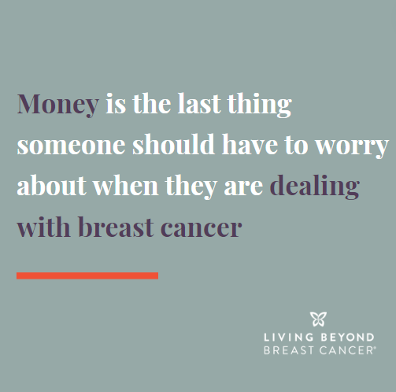  NOTE: Multi-slide graphic available for Instagram | According to the Centers for Disease Control (CDC), breast cancer has the highest overall treatment cost of any cancer in the U.S.  @livingbeyondbreastcancer provides grants to people in treatment to help pay the costs of rent, utilities, or other basic needs so they can focus on their health, not their bills. Since 2006, Living Beyond Breast Cancer has awarded over $3.5 million in grants to over 4,000 people diagnosed with breast cancer.  We’re proud to partner with Living Beyond Breast Cancer to help those diagnosed #Thrive365.  Sample CTA’s to choose from:  - Make a gift today: https://bit.ly/givetothrive365  - Shop X and $/% will support LBBC’s programs and services. | About LBBC
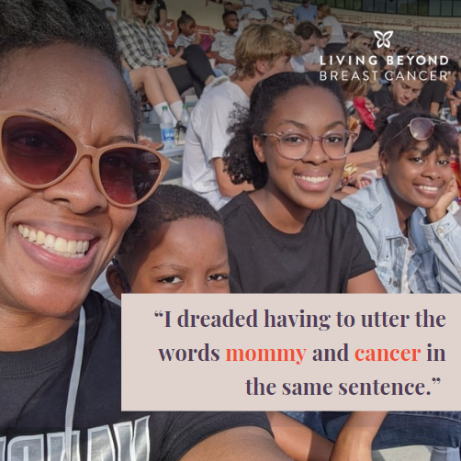 | Telling loved ones that you have breast cancer may be one of the hardest conversations you’ll have.  Living Beyond Breast Cancer’s Reading for Reassurance program provides parents with free books and resources written for kids of all ages to make having the cancer talk a little bit easier.  Since 2012, Living Beyond Breast Cancer has distributed 3,500 books to more than 1,700 families at no cost.  We’re proud to support LBBC to help those diagnosed #Thrive365. A $50 donation buys two books to help families with kids talk about breast cancer.  Make a gift to LBBC today: https://bit.ly/givetothrive365 | About LBBC
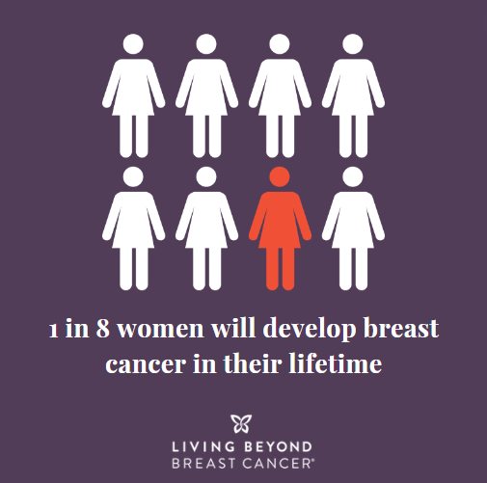 | Breast cancer is the most common cancer in women in the U.S., except for skin cancer. An estimated 310,720 women will be diagnosed this year alone.  We are proud to support @livingbeyondbreastcancer, who provides trusted medical information, emotional support, and stories of hope from their community of people who have been there.  With Living Beyond Breast Cancer by your side, you are not alone. Make a gift today to help more people #Thrive365: https://bit.ly/givetothrive365 | Breast cancer statistic
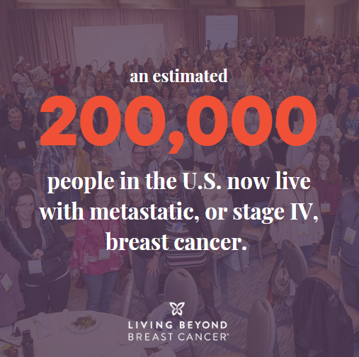 | Metastatic breast cancer is cancer that has spread beyond the breast to other parts of the body. While metastatic breast cancer is not curable, it is treatable, and researchers are continually developing more effective treatments.  @livingbeyondbreastcancer has provided resources for the metastatic community for over 18 years, including an annual conference, publications, and an advocacy program.  When you donate to Living Beyond Breast Cancer, you help those diagnosed with metastatic breast cancer #Thrive365.Give today: https://bit.ly/givetothrive365 | Breast cancer statistic
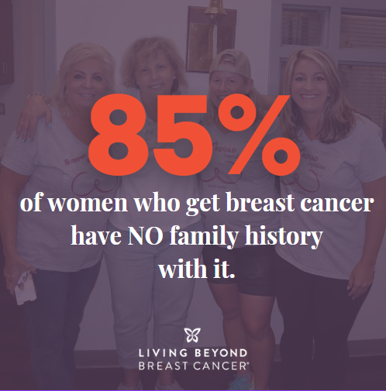 | Did you know that your risk for breast cancer is due to a combination of factors? Having a risk factor does not mean you will get the disease, and not all risk factors have the same effect.  Learn more at https://bit.ly/LBBCrisk and talk to your doctor about how to assess your risk of breast cancer. | Breast cancer statistic
X formerly Twitter
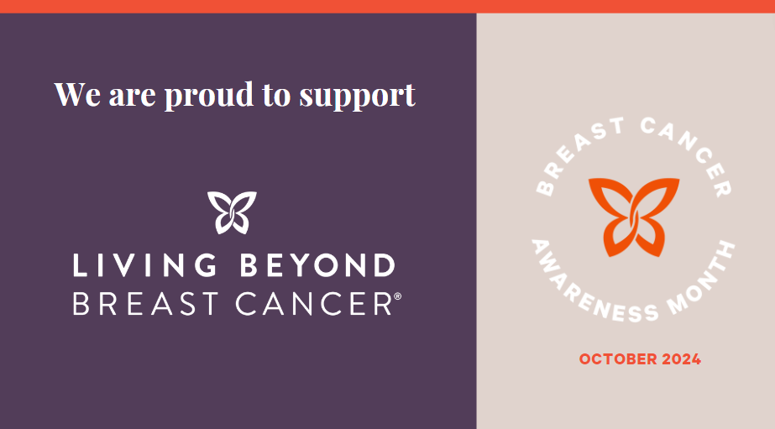 | We are proud to support @LivingBeyondBC this October by [enter brand promotion details]. LBBC helps people diagnosed with #breastcancer by providing trusted information and a community of support.  Sample CTA’s to choose from:  - Make a gift to LBBC today: https://bit.ly/givetothrive365  Shop X and $/% will support LBBC’s programs and services.
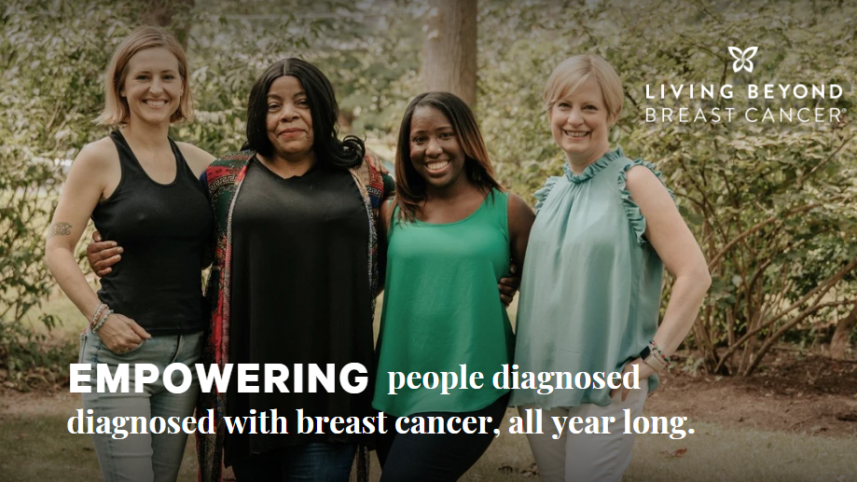 | Each year, @LivingBeyondBC helps over 600,000 people diagnosed with #breastcancer understand their options, make informed decisions, and connect to others who have been where they are. Support LBBC with a follow, share, or donation: https://bit.ly/givetothrive365
Recommended graphic:  Product image with LBBC logo overlay | This #BreastCancerAwarenessMonth, join us in supporting @LivingBeyondBC. From [promo dates] we will be [donating x% of profits] to LBBC to support their programs and services that help those diagnosed with breast cancer. Shop now: [link]
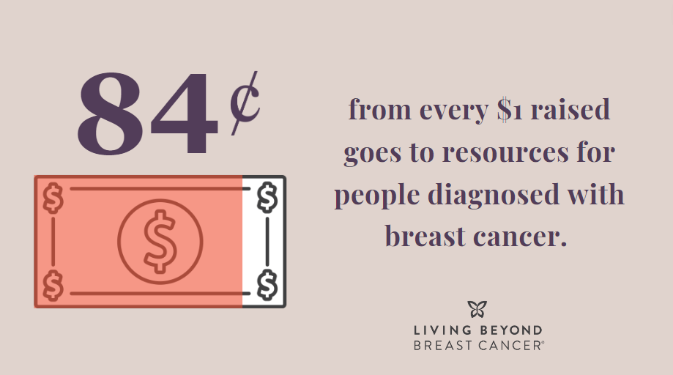 | @LivingBeyondBC is one of the highest-ranked breast cancer charities in the U.S. When you support them, 84 cents of every dollar goes directly to education and support services for people diagnosed with breast cancer. Donate to LBBC today: https://bit.ly/givetothrive365
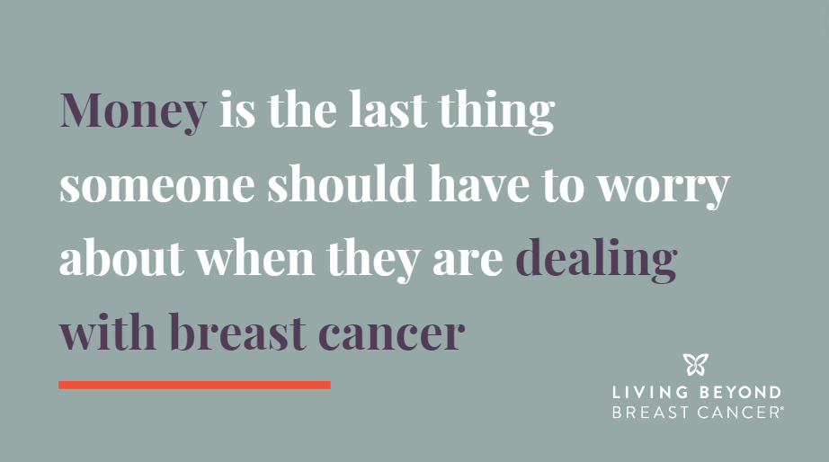 | According to the CDC, #breastcancer has the highest overall treatment cost of any cancer in the U.S. @LivingBeyondBC provides grants to people in treatment so they can focus on their health, not their bills. Donate to LBBC today: https://bit.ly/givetothrive365
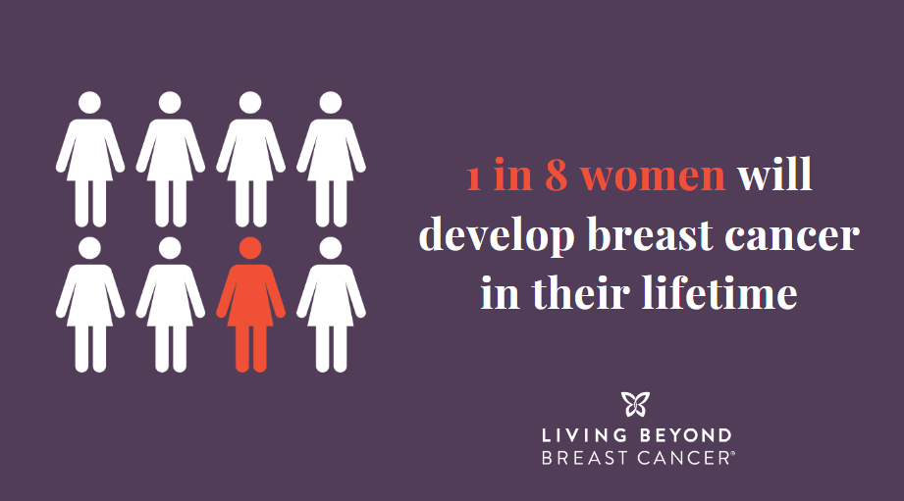 | An estimated 310,720 women will be diagnosed with #breastcancer in 2024. We’re proud to support @livingbeyondbreastcancer, who helps those diagnosed understand their options, make informed decisions, and connect to others who have been there. Learn more: https://bit.ly/LBBCabout
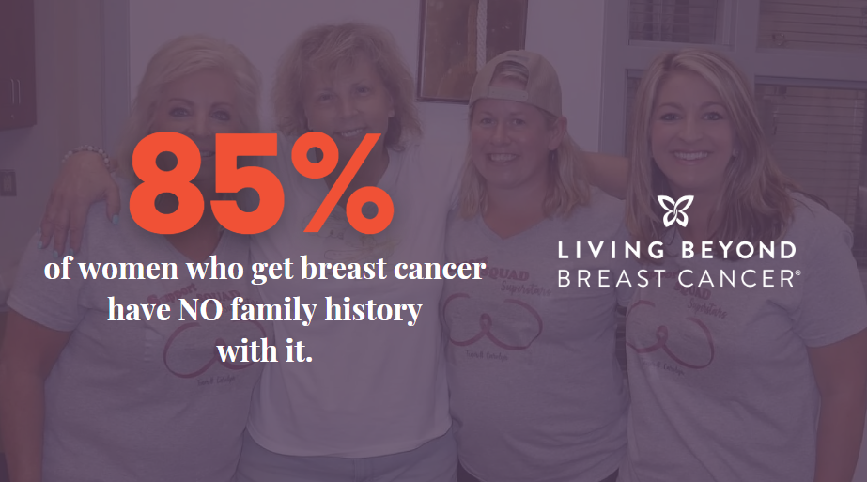 | Did you know that your risk for breast cancer is due to a combination of factors?  Learn more about risk factors for breast cancer at https://bit.ly/LBBCrisk and talk to your doctor about how to assess your risk of breast cancer.

